**Table of Contents**

**GETTING STARTED** 3

**0.** **CHECKLIST** 5

**SECTION ONE** 6

**1.** **IMPORTANT INFORMATION AND CONTACTS** 7

1.1. Safety Information 7

1.2. Contact Information 7

1.3. Student Conduct 9

**2.** **FORMS** 10

2.1. FORM 1: Student Declaration 10

2.2. FORM 2: Travel Itinerary 14

2.3. FORM 3: Health Declaration Form 15

2.4. FORM 4: Talent Release Form 17

2.5. FORM 5: Travel and Destination Safety Risk Assessment 18

2.6. FORM 6: Declaration for Fitness to Travel 19

2.7. FORM 7: Travel Bursary Conditions 20

2.8. FORM 8: Budget/Costings Proposal 21

2.9. FORM 9: EFT Form 23

2.10. FORM 10: Screenshot of Bank Statement Header 24

2.11. FORM 11: Journey Management Form 25

**SECTION TWO** 27

**SECTION TWO** 28

**3.** **SAP CONCUR PROFILE SET UP** 28

3.1. Concur Login 28

3.2. Concur Homepage 29

3.3. Concur Profile Set Up 29

**3.4.** **Creating a New Concur Request** 32

# **GETTING STARTED**

This booklet consists of two sections.

**Section One:** This section has some general information about safety and contacts for emergency situations. It also has all the forms that must be completed.

**Section Two**: This section is a Step-by-step guide to the UWA Travel site SAP Concur.

Once you have accepted your Regional Travel Internship placement, then you will need to plan your travel arrangements. This will require you to discuss and agree with your Internship Advisor and your Host Supervisor on what travel you will need to book.

Some organisations will do some or all of this for you, others will require you to book transport and accommodation yourself. Some of this expense can be covered by the McCusker Centre’s Travel bursary. Your Internship Advisor will liaise with you regarding this.

Once your travel plans have been agreed on, you will need to complete all the Forms in Section One and send them to the McCusker Internship team for approval.

[internships@mccuskercentre.uwa.edu.au](mailto:internships@mccuskercentre.uwa.edu.au)

Once approved you can then commence the process of arranging travel (e.g., booking flights, booking accommodation, etc) as advised by your Internship Advisor.

**Insurance Cover**



In order to comply with our Insurance arrangements, your APPROVED SECTION ONE document will need to be uploaded to the UWA SAP Concur Travel Site **BEFORE YOU TRAVEL**.

The SAP Concur Travel site will require you to set up a profile – details of how to do this is all outlined in Section Two.

**All Students** must comply with this **MANDATORY** process, regardless of whether you have requested a travel bursary, as it is required for Insurance purposes.

**Summary**

The following workflow is a summary to provide you with a better overview of the entire process.

## **CHECKLIST**

Ensure that you have formally accepted the offer from the McCusker Centre for Citizenship via email.

Schedule an initial conversation with your host Supervisor to ensure that you feel confident about the role, deliverables, and location, as well as to begin making arrangements for travel dates, transport and accommodation. You will also need to discuss information relevant to your travel forms with your supervisor.

Attend a mandatory regional travel pre-departure briefing with the McCusker Centre Internships Team.

Obtain a Police Clearance, Working with Children Check and/or NDIS worker screening (if required).

Attend to any other requirements as directed by your host Organisation before departure (such as online induction or training).

Read through this booklet, ensure that you completed all forms in Section One of this booklet (**from Page 7 to 26**) and send through to Internships team for approval **ASAP or** **at least two weeks prior to travel**.

Set up your SAP Concur account and complete your traveller’s profile

Create a New Concur Request in SAP Concur (see **SECTION TWO** **3.4 Creating a New Concur Request** **[Page 31]** for step-by-step instruction). Attach your Approved Travel Booklet to this request.

If you are approved for a travel bursary: Book your travel **as approved by the McCusker Centre for Citizenship** (only applicable for booking flights, train, or bus travel and/or accommodations)

If you received a travel bursary: complete a thank you letter to the donors.

|  |
| --- |
| **Mandatory forms for ALL Students to Complete:**  Form 1: Student Declaration  Form 2: Travel Itinerary  Form 3: Health Declaration  Form 5: Travel and Destination Safety Risk Assessment  Form 6: Declaration of Fitness for Travel  ***Required only for recipients of a travel bursary***  Form 7: Travel Bursary conditions  Form 8: Budget Costings/Proposal  Form 9: EFT form  Form 10: Screenshot of bank statement header  Form 11: Journey Management Plan  **Optional Form**  Form 4: Talent Release |

# **SECTION ONE**

*Once approved by the Internships team, please note that you will be required to complete and submit the entire Section One (****from Page 7 to 26****) onto your Concur Request*

## **IMPORTANT INFORMATION AND CONTACTS**

### Safety Information

Travel safety, security and health issues can happen at any time, and it is essential that all UWA students who are studying/interning regionally, or interstate remain informed and take particular care and responsibility for their own personal safety and health.

#### Safety When Travelling Regionally

Even when travelling within WA, there are many risks to your health and safety, including driving**1** on country roads (particularly unsealed roads), extreme weather conditions, and weather events. Please refer to the details and instructions outlined in this booklet as well as:

* Emergency WA - [https://www.emergency.wa.gov.au/](https://aus01.safelinks.protection.outlook.com/?url=https%3A%2F%2Fwww.emergency.wa.gov.au%2F&data=04%7C01%7C22984693%40student.uwa.edu.au%7Ce40d000406884d430ee308d8b6a4f3bf%7C05894af0cb2846d8871674cdb46e2226%7C1%7C0%7C637460166880304489%7CUnknown%7CTWFpbGZsb3d8eyJWIjoiMC4wLjAwMDAiLCJQIjoiV2luMzIiLCJBTiI6Ik1haWwiLCJXVCI6Mn0%3D%7C1000&sdata=C4F%2F1RnXdoA9HfL5an4YPyHQbD33eEc%2BiJhcGUjs0Fw%3D&reserved=0)
* The Bureau of Meteorology - <http://www.bom.gov.au/wa/warnings/>
* Main Roads - [https://travelmap.mainroads.wa.gov.au/Home/Map](https://aus01.safelinks.protection.outlook.com/?url=https%3A%2F%2Ftravelmap.mainroads.wa.gov.au%2FHome%2FMap&data=04%7C01%7C22984693%40student.uwa.edu.au%7Ce40d000406884d430ee308d8b6a4f3bf%7C05894af0cb2846d8871674cdb46e2226%7C1%7C0%7C637460166880304489%7CUnknown%7CTWFpbGZsb3d8eyJWIjoiMC4wLjAwMDAiLCJQIjoiV2luMzIiLCJBTiI6Ik1haWwiLCJXVCI6Mn0%3D%7C1000&sdata=zn6TcwlS5pN%2BwrRLV3TByrz2lZD7ERPap8ShR0dkMjE%3D&reserved=0)

Refer to UWA driver safety guidelines <https://www.safety.uwa.edu.au/health-wellbeing/physical/drivers>

### Contact Information

#### Emergency Contacts

In Australia, the following emergency phone numbers apply:

* Ambulance: [000](tel:000)
* Police (life-threatening): [000](tel:000)
* Police (assistance): [131 444](tel:131444)
* Mental Health Emergency Services:
  + Metro: [1300 555 788](tel:1300555788)
  + Peel: 1800 676 822
  + Regional and Rural: 1800 552 002

 Lifeline on [13 11 14](tel:131114)

* Roadside assistance in case of an emergency: 13 11 11 (RAC as an example)

#### Other Important Contacts

|  |  |  |
| --- | --- | --- |
| Contacts | Telephone | Email/Website |
| McCusker Centre for Citizenship (during office hours) | +61 8 6488 7553  +61 8 6488 1690 | [internships@mccuskercentre.uwa.edu.au](mailto:internships@mccuskercentre.uwa.edu.au)  [info@mccuskercentre.uwa.edu.au](mailto:info@mccuskercentre.uwa.edu.au) |
| UWA Insurance Broker |  | Aon Risk Services ([uwainsuranceteam@aon.com](mailto:uwainsuranceteam@aon.com))  <https://www.spp.uwa.edu.au/riskandlegal/insurance#student_insurances>  <https://www.uwa.edu.au/covid-19-faq/Home/2---Travel-advice> |
| UWA Counselling/ Psychological Services  *Students who are travelling (even overseas) can still utilise UWA’s Student Support Services. Consultations can be provided online or by phone.* | +61 8 6488 2423 | Find more information at <https://www.uwa.edu.au/students/Support-services/>  Further information regarding **Workplace safety** can be found in the [**Internships Guide**](https://mccusker-centre.cdn.prismic.io/mccusker-centre/aB18vCdWJ-7kRzNp_V6.7InternshipGuideforStudents-May2025-.pdf)**.** |

***Record below your emergency contact information***. This may include family and/or friends. **We will contact this person in case of an accident or if we cannot get hold of you.**

|  |  |  |
| --- | --- | --- |
| Contact: Name | Relationship | Telephone/Email |
|  |  |  |
|  |  |  |
|  |  |  |
|  |  |  |

### Student Conduct

As per UWA Safety advice, students undertaking activities in external organisations are expected:

* To comply with all health and safety requirements of the host organisation.
* Take reasonable care of your own health and safety and also that of others.
* You must report all known or observed [incidents, injuries, illness, near misses and hazards](https://www.safety.uwa.edu.au/incidents-injuries-emergency) to the host organisation and to the UWA Internships Adviser.
* Cultural differences must be respected.
* Respect the right of others to work free from discrimination.
* You must report any breaches of health and safety legislation, equal opportunity legislation (including sexual harassment, racial vilification) or poor personal security (including whilst on home visits to patients) to the host organisation and to the UWA Internships Adviser.
* A breach of the above may result in the placement being suspended and/or may be considered as student misconduct for the purposes of UWA policy.

It is important that while travelling, you remember you undertaking study and UWA Student Conduct guidelines apply. See <https://www.uwa.edu.au/students/my-course/student-conduct> for more information.

In particular, note (d) 'professional misconduct': this is inappropriate behaviour by a student of the University whilst undertaking a component of their course of study either internally or externally (that is, professional/clinical placement, field trip, inter-institutional units) that, while not constituting academic misconduct, constitutes a breach of standards of professional conduct expected within that field of study;”

## **FORMS**

### FORM 1: Student Declaration

**Requirement for all students**

**DEFINITIONS**

“Host Country” means the country where the Program will take place, should the internship be an overseas opportunity (outside Australia).

“Host Organisation” means the partner organisation, separate to The University of Western Australia that is responsible for hosting and supervising the Student throughout the internship.

“Program” means the McCusker Centre for Citizenship Internship Program.

“McCusker Centre” means the McCusker Centre for Citizenship at The University of Western Australia.

“Student” means the student intern who is undertaking the internship.

“UWA” means The University of Western Australia.

**RESPONSIBILITIES OF STUDENT**

In accepting an internship as part of the McCusker Centre for Citizenship Internship Program (herein referred to as the “Program”), I understand and agree to the following:

**Pre-Departure Preparation**

1. I will adhere to the specific Program pre-departure information as advised by the host organisation including but not limited to associated codes of conduct, particular requirements and expectations of the activity, health and safety services and protocols, including requirements for medical and legal checks.
2. I will take an active role in preparing for the Program and understand the specific requirements of the Host Organisation, McCusker Centre and UWA.
3. I will complete any required training or development sessions (pre-departure sessions) provided by the UWA and/or the Host organisation.

**Code of Conduct**

1. Whilst engaged in the Program, I shall be bound by the rules, regulations policies, statutes, protocols and by-laws of UWA (see <https://www.governance.uwa.edu.au/regulations/student-conduct>) and the Host Organisation.
2. I shall observe and appropriately maintain the standards of dress and behaviour in keeping with the nature and purpose of the Program.
3. I understand that UWA and/or the Host Organisation may take any disciplinary action, including withdrawing my participation from the Program for any violation of applicable rules and regulation as established in Item 4 or for conduct that could bring UWA and or the Host Organisation into disrepute.
4. I will be subject to the laws of the host country and any other country I may visit during the Program. It is my responsibility to familiarise myself with and understand details of these laws and obey these laws and cultural norms, while in country (Information on host country laws is available from the Department of Foreign Affairs and Trade at [www.dfat.gov.au](http://www.dfat.gov.au)). In the event of any breach of law, I may be subject to immediate disciplinary action by UWA and/or the Host Organisation. This may include dismissal from the Program and return home, at my own expense.

**Academic and Program Responsibilities**

1. I must maintain my enrolment at UWA for the entire period of my Program.
2. I will work to fulfil the duties of the Program within the stated times established with the Host Organisation.
3. I will respect the confidentiality of the Host Organisation. No reports in the form of oral, written, graphic or electronic information pertaining to the Host Organisation, or its operations will be made available to any person or company without the consent in writing of the Host organisation. If the Student wishes to utilise information gained during the Program after the completion of the Program, prior consent in writing must be obtained from the Host Organisation, and any material so produced must be approved by the Host Organisation before release.
4. I will abide by any agreement made between UWA and the Host Organisation and will not undertake any independent negotiations with the Host Organisation.
5. I will perform all reasonable requirements of the Host Organisation and meet all statutory requirements and workplace codes of practice including those related to occupational health and safety.
6. I agree to inform UWA or the Host Organisation immediately after any event occurs or circumstances change that materially affects my participation in the Program.

**Health, Safety and Security Obligations**

1. I am responsible for disclosing any pre-existing medical condition which may require additional support or impact on progress in the Program, to UWA, prior to departure.
2. I am responsible for complying with any vaccination requirements or other health requirements for entry into the host country, as advised by the Host Organisation or immigration authorities of the host country.

**Travel Responsibilities**

1. As a participant of the Program I am covered, for the duration of travel in the Program, by UWA's Corporate Travel Insurance. I have read the Schedule of Benefits (<https://www.spp.uwa.edu.au/riskandlegal/insurance#student-insurances>). I understand the scope and limitations of the policy. I understand that it is my responsibility to ensure that I am adequately covered for all additional travel and medical insurance, beyond the coverage provided by UWA.
2. It is my responsibility to provide proof of travel insurance to an acceptable level as advised by UWA and the Host Organisation.
3. It is my responsibility to secure information and make all arrangements for transportation and any necessary travel and, in the case of overseas travel, immigration documents (e.g. passport, visas, working rights).
4. I understand that I am advised against booking any travel (directly or indirectly related to my placement destination) until I have, both, official acceptance from my Host Organisation and any necessary travel and immigration documents (e.g. passport, visas, study permits).
5. It is my responsibility to book any relevant travel through my preferred travel provider.
6. In accordance with the University Travel Policy, I must submit my travel itinerary to Concur as per Section Two of this booklet.
7. For my own safety I must carry with me at all times emergency numbers for my family or next of kin, my local contact at the Host Organisation and the emergency numbers provided by UWA.
8. In the event of unforeseen circumstances, which result in an emergency situation including, but not limited to, natural disasters, civil unrest, public health concerns, or outbreak of war, UWA may recall me from my study program for my own personal safety. I will take all necessary measures to comply with UWA's instruction and advice under these circumstances.
9. I will ensure that I make myself available for the pre-departure briefing with the McCusker Centre for Citizenship and in particular note what steps to take in an emergency situation.
10. I am responsible for maintaining regular contact with the McCusker Centre at UWA and the Host Organisation throughout the period of travel in the Program.

**Financial Responsibilities**

1. I must pay or maintain my financial obligations to UWA, for the following fees and expenses, for the entire duration of the Program:
   1. my student contribution (HECS-HELP) or if I am an International Student, all fees in accordance with Fees detailed in my Acceptance of Offer contract;
   2. Other compulsory UWA fees
   3. Any additional compulsory medical fees required by the Host Organisation
   4. All personal expenses associated with the general cost of living in the host location
   5. All costs associated with 14 and 15 above, unless agreed to by UWA
   6. All costs associated with modification or termination of my participation in the Program, unless agreed to by UWA
2. If I have been awarded a McCusker Centre travel bursary, I must successfully complete my Program (as determined by UWA) or I may be required to repay all or a portion of the bursary.

**Accommodation Responsibilities**

1. If accepted into the Program, I understand that it is my responsibility to secure appropriate accommodation (with the help of the Host organisation).

**Ambassadorial Responsibilities**

1. I will conduct myself as an Ambassador of UWA and not do, or omit to do, anything that would adversely alter the reputation and standing of UWA or the course.
2. To fulfil my ambassadorial responsibilities, I give permission to UWA to share my email address with
   1. all UWA students in my Program cohort
   2. any UWA student who may be interested in the same Program

**Other Responsibilities**

1. In accordance with UWA's Information and Privacy Policy and Confidentiality of Student Records Policy, I consent to UWA releasing my personal information in the following circumstances:
   1. If UWA is obliged to do so because it is a legal or academic requirement
   2. If UWA considers it an emergency for the safety of myself or others
2. I understand that I must use my UWA student email account during the Program, as all official correspondence from UWA will be directed to this account.
3. I will notify UWA of my other contact details (mobile phone, residence) within the first three days of arrival and will update UWA through StudentConnect of any changes to my contact details.

**Evaluation**

1. I agree to participate in feedback and evaluation activities in the course of the Placement and at its completion, concerning individual progress and outcomes.

**Acknowledgement, Release and Assumption of Risk**

1. Subject to the UWA Corporate Travel Insurance, I hereby release UWA and its employees, servants, agents or contractors from any and all liability for death, disability, personal injury, property damage, property theft and all other foreseeable risks claims or actions of any kind (including breach of contract and negligence) that I may have or may at any time have had arising from or in connection with, directly or indirectly, my participation in the Program.

**Declaration**

I agree that the information I have supplied on this form, is true, complete and correct. I confirm that I have not provided false information of my citizenship or immigration status. I confirm that I have not allowed UWA to act upon information about my citizenship, or immigration status, that I know to be incorrect. I have access to the financial resources necessary to undertake the Placement. If any liability shall arise to UWA as a result of my providing false or misleading information, I agree to indemnify UWA for any such liability.

**Signature**: **X** Date:

### FORM 2: Travel Itinerary

**Requirement for all students**

Approved by

Supervisor’s name: ________________________

Supervisor’s signature: **X** _____________________

***Note: This form needs to be discussed and endorsed by your internships host supervisor before commencing your internship. Please fill in where applicable.***

|  |  |  |  |  |  |  |  |  |  |  |  |  |  |  |  |  |  |
| --- | --- | --- | --- | --- | --- | --- | --- | --- | --- | --- | --- | --- | --- | --- | --- | --- | --- |
| Purpose | |  | | | | | | | | | | Trip Start  *(dd/mm/yy)* | |  | | | |
| Destination | |  | | | | | | | | | | Trip End  *(dd/mm/yy)* | |  | | | |
| FLIGHTS/TRAIN | | | | | | | | | | | | | | | | | |
| Date | | | Departure Time | | Departure Airport | | Flight Number | | Arrival Time | | Arrival Airport | | | | More Information | | |
|  | | |  | |  | |  | |  | |  | | | |  | | |
|  | | |  | |  | |  | |  | |  | | | |  | | |
|  | | |  | |  | |  | |  | |  | | | |  | | |
|  | | |  | |  | |  | |  | |  | | | |  | | |
| CAR/ROAD TRIPS | | | | | | | | | | | | | | | | | |
| Date | | | Departure From | | | Destination | | | | | Travel Distance | | More Information (Driver etc) | | | | |
|  | | |  | | |  | | | | |  | |  | | | | |
|  | | |  | | |  | | | | |  | |  | | | | |
|  | | |  | | |  | | | | |  | |  | | | | |
|  | | |  | | |  | | | | |  | |  | | | | |
|  | | |  | | |  | | | | |  | |  | | | | |
|  | | |  | | |  | | | | |  | |  | | | | |
| ACCOMMODATION | | | | | | | | | | | | | | | | | |
| Check in date | | Check out date | | Accommodation Name | | | | Accommodation Address | | | | | | | | Booking Reference | Accommodation Contact Number |
|  | |  | |  | | | |  | | | | | | | |  |  |
|  | |  | |  | | | |  | | | | | | | |  |  |
|  | |  | |  | | | |  | | | | | | | |  |  |
|  | |  | |  | | | |  | | | | | | | |  |  |
|  | |  | |  | | | |  | | | | | | | |  |  |
| OTHER ACTIVITIES | | | | | | | | | | | | | | | | | |
| Date | Venue | | | | | | | | | Additional Information | | | | | | | |
|  |  | | | | | | | | |  | | | | | | | |
|  |  | | | | | | | | |  | | | | | | | |
|  |  | | | | | | | | |  | | | | | | | |
|  |  | | | | | | | | |  | | | | | | | |
|  |  | | | | | | | | |  | | | | | | | |

### FORM 3: Health Declaration Form

**Requirement for all Students**

***Note: Submission of the form is essential, but you are under no obligation to disclose any medical information that you do not wish to share.***

Student signature to waive if requested:

_____________________________

Date: _______________________

**HEALTH DECLARATION FORM**

**The information you choose to disclose is optional.**

**Students are under no obligation to disclose confidential medical information. Students may wish to disclose information if they feel that their condition may impact on their participation in the program. They may also choose to disclose information that may assist Program Coordinators in responding, in the case of an emergency.**

**Information will be kept in the strictest confidence and will be confidentially filed (with restricted access) on your student record upon completion of the program**

**Name _________________________________________________________________________**

**Student Number ____________________________________________________________**

**PRESCRIBED AND OVER THE COUNTER MEDICATION (*Optional)**

|  |  |  |  |
| --- | --- | --- | --- |
| **Name of Drug** | **Condition for which I am taking** | **Prescribed dosage** | **Any side effects/issues to be aware of** |
|  |  |  |  |
|  |  |  |  |

**ANY OTHER CONDITIONS (*Optional)**

Please list any allergies or conditions which we should be aware of (e.g. bees, medication, and diabetes) that may impact on your participation in the program. In the case that you may require medical attention this information may be used to assist in your treatment. ____________________________________________________________________________________________________________________________________________________________________________________

Blood Group (if known): __________________________________________________________________

Name and address of general practitioner (*Optional) __________________________________________________________________________________________

**Participant’s Declaration:**

In signing the below table:

* I declare I have received appropriate medical advice and disclosed to my Work Area Manager / Supervisor any limitation imposed by my health that may affect my ability to participate safely in the travel and work activity I will (or intend to) undertake.
* I declare that I am adequately fit for the tasks required to participate in the travel and work or activity outlined in this application.
* I declare that I have received and will follow relevant medical advice concerning the avoidance of health risk and treatment of any medical condition during the travel and work or activity.
* I confirm that I have discussed the risks involved and proposed risk mitigation strategies with my supervisor/manager. I also confirm that I agree with the risk assessment and mitigation strategies as documented in this Travel and Destination Safety Risk Assessment form and that I will comply with and implement those risk mitigation strategies.

**Signature X** ____________________________________ **Date** ____________________

### FORM 4: Talent Release Form

**This form is optional**

While you are on your placement, we may request that you send our communications officer photos of your experiences, as well as responses to a few brief questions. This content is an important avenue for the Centre to raise awareness and interest about the important programs that we run. As one of our regional/interstate/global interns, you are not only representing The McCusker Centre for Citizenship and UWA at your host organisation, but you are also representing the Centre to the wider regional community.

By signing and submitting this form, **you are providing the McCusker Centre for Citizenship permission to use your images to advertise the Centre’s units and projects to the local community and to global partners**.

The images you send us may be used by UWA in print, electronic and digital publications created, as well as on official websites, social media channels (YouTube, Facebook, Twitter, Snapchat and Instagram) and mobile apps managed.

**By signing below, you as the copyright owner are indicating that you give your permission for Student Services to use the image, audio and video content you are featured in.**

|  |  |
| --- | --- |
| **Signature:** | **X** |
| Name (please print) |  |
| Student Number |  |
| Contact email address |  |
| Mobile phone number |  |
| Date |  |

**STAFF USE ONLY**

Content gathered as part of the Student Communications Strategy (under the ‘This is...’ project or for our websites, social media channels, hard-copy publications or mobile app) should be curated and stored appropriately. A copy of this completed Copyright Permission form should be forwarded to the Communication Strategy team and the details below should be filled in.

Staff member (name):

Project:

Files to be stored (location):

### FORM 5: Travel and Destination Safety Risk Assessment

**Requirement for all Students**

Student travelling to regional locations as part of their internships must be aware that they place themselves in a situation where they are exposed to certain levels of risk. This table below helps you to consider all potential risks involved in your regional travel. Please complete it to your best knowledge.

|  |  |  |  |
| --- | --- | --- | --- |
| **Determine Potential Safety Risk Factors:**  ***TickR the below boxes to signify identified Travel safety related risks*** | | | |
| **Flying** | **Transport other than flight** | **Accommodation or Camp Site** | **Political, Cultural, or religious** |
| Risks to consider when flying:  Fatigue from long flights  Increase exposure to illness  Non-Reputable airlines i.e. developing country airlines  Aircraft chartered or low-grade  Loss of vital equipment to carry out works safely  Other: | Is a hazard present from other means of transport?  Off road 4 wheel drive  Unlicensed or experimental equipment  Boats  Long distance >2hrs driving  Unsealed/Gravel roads  Towing or carrying heavy loads  Other: | Are there hazards from the accommodation or campsite location?  Potential of theft  Harassment, hostile persons  Terrain  Falling tree branches  Flash flooding  Wildlife/stock  Vehicles  Other: | Consider the following risks:  Are there different cultural values than you are accustomed to?  Is the topic/reason for your visit associated with a highly political or contentious issue?  Stability of the government. |
| **Communications** | **Fatigue and Stress** | **Personal** | **Weather and Climate** |
| Is there a hazard from poor communications?  Inadequate communication plan  Isolated/remote location  Poor phone and or internet service  Communication across time zones  Different languages spoken or written  Unfamiliar jargon - when working with contractors or specialist  External factors i.e. background noise  Other: | Impacted by self transport  Impacted by travel between time zones  Impact from fieldtrip preparation  Impacts from known fatigue increasing tasks i.e. diving  Are works being conducted over long duration or increased hours than normal work?  Are financial or other stresses impacting individual ability to focus?  Is there or should there be a fatigue management plan?  Other: | Are there personal factors for any member involved in the activities that may increase risk to themselves or others?  Does any party involved have Medical condition?  Low physical fitness relative to tasks to be undertaken?  Sensitivity or Susceptibility ?i.e. allergic reactions or increase due to medications being taken i.e. sensitive to sunlight  Personal fears or phobias?  Mobility that may affect helping themselves or others  Other: | Can anyone suffer ill health due to:  Unfamiliar climatic conditions  Working at altitude  Atmospheric contamination -Poor air quality  Exposure to high temperatures  Exposure to low temperatures  Other: |

|  |
| --- |
| Comments – Provide further comment on the safety risk factors identified in Section above:  1. –  2. –  3. –  4. –  5. – |

### FORM 6: Declaration for Fitness to Travel

**Requirement for all Students**

|  |  |  |
| --- | --- | --- |
| **Please complete the following declarations, provide your name, signature and date.** | | |
| I declare I have received appropriate medical advice and disclosed to my Work Area Manager / Supervisor any limitation imposed by my health that may affect my ability to participate safely in the travel and work activity I will (or intend to) undertake.    I declare that I have received and will follow relevant medical advice concerning the avoidance of health risk and treatment of any medical condition during the travel and work or activity.  I declare that I am adequately fit for the tasks required to participate in the travel and work or activity outlined in this application.  I confirm that I have discussed the risks involved and proposed risk mitigation strategies with my supervisor/manager. I also confirm that I agree with the risk assessment and mitigation strategies as documented in the Travel And Destination Safety Risk Assessment [Form 5] and that I will comply with and implement those risk mitigation strategies.  I have completed the required Placement Induction Program (PIP) Occupational Health and Safety Module and all aspects of my Safety and Health Training are up-to-date for the duration of this trip.  ***Required only for students travelling via self-transport, i.e., driving own vehicle***  I confirm that I have completed the UWA Journey Management form: Form 11 on Page 25 & 26 | | |
| Traveller’s Name: | Traveller’s Signature: | Date: |
| Work Area Manager/Supervisor Name: | Work Area Manager/Supervisor Signature: | Date: |
| Where more than one person is travelling to the same destination as covered in this risk assessment, please ensure all person complete their individual ‘Declaration for Fitness to Travel’. | | |

### FORM 7: Travel Bursary Conditions

**Required only for recipients of a travel bursary**

***Note: Students undertaking regional internships may receive travel assistance from the McCusker Centre for Citizenship. The amount is at the discretion of the Director of the McCusker Centre.***

In accepting this travel bursary, I hereby agree to abide by the following conditions:

1. If I withdraw prior to commencement of my internship for whatever reason, I will be required to repay the full amount of the bursary within 14 days of my notification of withdrawal.
2. If I withdraw after my internship has commenced, I will notify the McCusker Centre for Citizenship and understand that I may be required to refund all or part of the bursary.
3. If I do not successfully complete my unit requirements as determined by UWA, I understand that I may be required to refund all or part of the bursary.
4. I understand that payment may take some time, and I may not receive my funds until during the internship.
5. I understand that I am responsible for booking any related travel through my preferred travel provider.
6. I understand that I must submit my travel itinerary to Concur prior to departure and submit any revised travel itineraries related to the program to Concur as soon as possible.
7. I understand that I am responsible for my enrolment and must seek faculty or Course Coordinator approval where applicable.
8. I understand that if I fail or do not successfully complete my internship, I will be required to pay back some or the entire bursary amount.
9. Upon completion of the internship, I am required to write a letter of thanks to the benefactor of my travel bursary.

**Signature of Student**

**X** _____________________________

Date:

**Signature of McCusker Centre for Citizenship Representative**

**X** _____________________________

Date:

### FORM 8: Budget/Costings Proposal

**Required only for recipients of a travel bursary**

***Note: Please complete and submit the form there, after speaking with your internship supervisor. Your proposal will help to determine the bursary amount.***

The McCusker Centre for Citizenship (the Centre) is committed to providing students with the opportunity to undertake regional internships with our regional partners. To assist with the financial cost to students of undertaking a regional internship, the Centre works closely with our partners to minimise costs and to contribute to reasonable expenses for the student.

Expenses are likely to vary according to the location of the host organisation, the time required for the student to be in the region and any availability of funding from the host organisation.

Once the intern has been introduced to the Host Supervisor, the intern is to work with the Host Supervisor in completing the Budget/Costings Proposal form for reasonable expenses (see form below). The form needs to be signed and endorsed by Host Supervisor. Intern is also required to complete the EFT Form and provide a Screenshot/Copy of Bank Statement when submitting the Budget/Costing Proposal form.

**PLEASE NOTE THAT THE APPROVED BUDGET CAN ONLY BE TRASFERRED ONCE ALL FORMS HAVE BEEN COMPLETED AND SUBMITTED.**

**MCCUSKER CENTRE FOR CITIZENSHIP REGIONAL INTERNSHIP**

**BUDGET PROPOSAL FORM**

|  |  |
| --- | --- |
| **STUDENT NAME** |  |
| **HOST ORGANISATION** |  |
| **LOCATION** |  |
| **TIME FRAME OF STUDENT REQUIRED AT HOST ORGANISATION** |  |

***TO BE PROVIDED BY HOST ORGANISATION (e.g., Accommodation)***

|  |  |  |  |
| --- | --- | --- | --- |
| **ITEM** (e.g. Flight, car trip, Accommodation) | **DESCRIPTION** (e.g. Provider and booking reference, From – to, km to travel) | **COST** | **NOTES** (requirement of trip) |
| *e.g. Accommodation* | *3 nights’ accommodation* | *$300* | *Student to commence internship* |
|  |  |  |  |
|  |  |  |  |
|  |  |  |  |
|  |  |  |  |
|  |  |  |  |
|  |  |  |  |
|  |  |  |  |
|  |  |  |  |
| **TOTAL COST:** | |  |  |

***TO BE PROVIDED BY THE McCusker Centre for Citizenship (e.g., Mileage)***

|  |  |  |  |
| --- | --- | --- | --- |
| **ITEM** (e.g. Flight, car trip, Accommodation) | **DESCRIPTION** (e.g. Provider and booking reference, km to travel) | **COST** | **NOTES** |
| *e.g. Car trip* | *Home – Host organisation, 217 km (L/100km per km)* | *$35* | *Student to commence internship* |
|  |  |  |  |
|  |  |  |  |
|  |  |  |  |
|  |  |  |  |
|  |  |  |  |
|  |  |  |  |
|  |  |  |  |
|  |  |  |  |
| **TOTAL COST:** | |  |  |

I, ______________________________, host internship supervisor at ______________________________ acknowledge that the total proposed amount above is the essential travel cost for ___________________________ to complete the internship in [year] ____.

Supervisor signature: **X** _____________________________

Date (please print): _____________________________

Name of Supervisor (please print): ________________________________________________________

Address (please print): ____________________________________________________________________

***Confirmed by McCusker Centre for Citizenship Representative:***

Industry Partnerships Manager Signature: **X** ______________________________________________

Date (please print): _____________________________

Name of Industry Partnerships Manager (please print): ____________________________________

### FORM 9: EFT Form

**Required only for recipients of a travel bursary**

***Note: Please complete form below and ensure bank account details provided matches your screenshot of Bank Statement Header.***

**AP**

**Electronic Funds Transfer (EFT) Details Domestic**

**This form is to be completed by the supplier**

**Vendor ID (or Staff/ Student Number, if applicable)**

**Vendor (Student) Name**

**Vendor (Student) Bank Details**

Name of Financial Institution

(ie. Westpac, NAB etc.)

Address/ Branch of Financial Institution

Suburb

State

Postcode

Vendor Australian Business Number (ABN)

BSB Number

Account Number

E-Mail Address (For correspondence and notifications)

E-Mail Address (For receipt of remittance advice only)

Please support the above with evidence of your bank details for verification i.e. Bank statement header (no balances required) deposit slip or invoice.

Please note that the standard payment terms are 30 days from end of the month in which the invoice is issued.

For timely payment of invoices suppliers must quote a valid UWA Purchase Order number on all invoices, correspondence and enquiries.

In relation to the above bank details submitted to The University of Western Australia, I certify the bank information is correct. I understand that funds paid to an unintended recipient due to errors or omissions in the information supplied on this form may not be recoverable and The University of Western Australia reserves the right in these circumstances to consider that no further liability exists in relation to the invoice/s involved.

I also warrant that future changes to bank details will be advised in writing to Accounts Payable, The University of Western Australia (accountspayable@uwa.edu.au).

**This form is to be signed by the vendor or the personnel receiving funds only.**

|  |  |  |  |
| --- | --- | --- | --- |
| Position: |  | Name: |  |
| Phone: |  | Signature: |  |
| Fax: |  | Date: |  |

|  |  |  |  |
| --- | --- | --- | --- |
| For Completion by Financial Services | | | |
| Vendor ID | __________________________________ | Approved By | __________________________________ |
| Date | __________________________________ | Approval Date | __________________________________ |
| Actioned By | __________________________________ | Comments | __________________________________ |

### FORM 10: Screenshot of Bank Statement Header

**Required only for recipients of a travel bursary**

**Note: Provide a screenshot of your Bank Statement the space below.**

**Please ensure the screenshot captures the following information:**

* **Bank name in the form of logo**
* **Full account holder name (not an account ‘nickname’, and not the mailing address)**
* **BSB**
* **Account number**
* **If dated, document must be issued within last 6 months**

***We do not need to see anything confidential (e.g., account balances or transactions), these may be blanked out in your screenshot. Please kindly copy & paste a screenshot of your Bank Statement Header in the blank space below***

### FORM 11: Journey Management Form

****Required only for recipients of a travel bursary and for students travelling via self-transport, i.e., driving own vehicle**

**Journey Management Form**

|  |  |  |  |  |  |  |  |
| --- | --- | --- | --- | --- | --- | --- | --- |
| This form must be completed for trips that are not considered fieldwork but still require a detailed record of the planned travel. A form must be completed for each vehicle. Air travel booked in Concur is considered an equivalent record and does not need a journey management form. | | | | | | | |
| I have considered options that eliminate exposure to driving related hazards and have determined that this trip is still necessary. | | | | | | | Yes |
| Driver 1: | | Does the driver hold a valid in date driver’s licence for the class of vehicle being operated? | | Yes | Mobile: | | |
| Driver 2: | | Yes | Mobile: | | |
| Driver 3: | | Yes | Mobile: | | |
| Vehicle Make, Model & Colour: | | | | | Rego No: | | |
| Passenger 1: | Mobile: | | Passenger 2: | | | Mobile: | |
| Passenger 3: | Mobile: | | Include a passenger list with mobile numbers, if trip involves more than 3 passengers. | | | | |

|  |
| --- |
| **By signing this form, all drivers agree:** |
| 1. Appropriate valid licenses are being held by all drivers. 2. Before the start of the trip, they will be fit to drive, well rested and alert, not under the influence of drugs, alcohol, medications, or other substances that may impair their ability to drive. 3. All vehicle occupants will wear seatbelts. 4. To check the weather, road, and traffic conditions prior to commencing and as required during the trip. For weather: Bureau of Meteorology <http://www.bom.gov.au/>   For road conditions: Main Roads WA: https://travelmap.mainroads.wa.gov.au/Home/Map For traffic conditions: Google Maps: https://[www.google.com.au/maps](http://www.google.com.au/maps)   1. The vehicle used is inspected, roadworthy, free of mechanical faults and fit to handle the weather and driving conditions. 2. Sufficient time has been allowed to complete the trip based on road, weather, and traffic conditions at the time of this trip. 3. 2WD vehicles will not be driven on roads suitable for 4WD vehicles. 4. A driver or rider of a vehicle can only touch a mobile phone to make or receive a phone call if the phone is secured in a mounting affixed to the vehicle or if they use hands free (no texting, emails or video calls). GPS may be used by a driver whilst driving if no touch of the keypad or screen is required. |

|  |
| --- |
| **Emergency communication** |
| We recommend that communication should be made with the emergency contact at each of the following:   * Departure from start location * Arrival at destination * Unscheduled stops / breakdowns * Route deviations * Any changes in planned activities |

|  |  |
| --- | --- |
| Signature Driver 1: | Date: |
| Signature Driver 2: | Date: |
| Signature Driver 3: | Date: |

# **SECTION TWO**



# **SECTION TWO**

## **SAP CONCUR PROFILE SET UP**

All students travelling regionally are required to upload their travel booklet onto SAP Concur for their placement insurance purposes.

### Concur Login

Prior to using Concur, ensure you have set up your Pheme account and your UWA student email address is activated.

To log in to SAP Concur, use one of these methods:

**Method 1:** Go to [My Apps](https://myapplications.microsoft.com/) (myapplications.microsoft.com) and select SAP Concur (or Search)



**Method 2:** Go to [SAP Concur](https://aus01.safelinks.protection.outlook.com/?url=https%3A%2F%2Fwww.concursolutions.com%2F&data=04%7C01%7Cdione.szabo%40uwa.edu.au%7Cf9222c6946364cafc74a08d98888f65a%7C05894af0cb2846d8871674cdb46e2226%7C1%7C0%7C637690944095937489%7CUnknown%7CTWFpbGZsb3d8eyJWIjoiMC4wLjAwMDAiLCJQIjoiV2luMzIiLCJBTiI6Ik1haWwiLCJXVCI6Mn0%3D%7C1000&sdata=Tojr0FKz3dnbKy2633TMk0yOC5wVntC%2BbaEJbqo4oKg%3D&reserved=0) ([www.concursolutions.com](http://www.concursolutions.com/)). On the “Sign In” screen enter your [studentnumber@uwa.edu.au](mailto:studentnumber@uwa.edu.au) then click “Next”



1. Click “Sign in with UniID” and enter your Pheme password.



**Note:** For best user experience, Concur recommends the use of Internet Explorer version 10 or later; Google Chrome version 30 or later; or Mozilla Firefox version 25 or later.Ensure pop-ups are enabled.

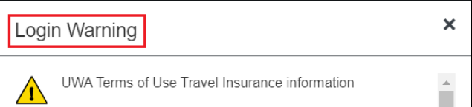

**Note:** A login warning window will appear. Please ensure that you read and be aware of the UWA Terms of Use. By logging in and using the Concur Travel Management System, you acknowledged your compliance to the UWA Terms of Use.

To continue, click on “**OK**” at the bottom of the page.

### Concur Homepage

Your Concur Homepage may appear similar to the following, depending on your user access level.

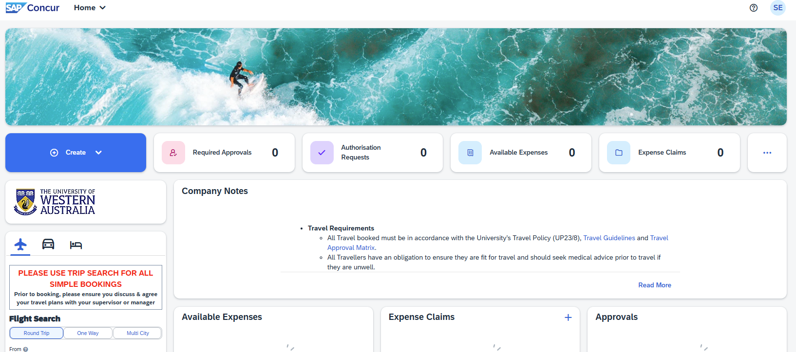

### Concur Profile Set Up

If you are logging in for the first time, you are required to review and complete your Traveller Profile.

**Note:** Traveller **MUST** review and confirm their profile information.

1. To update your Traveller’s profile, click on “Profile” > “Profile Settings”.

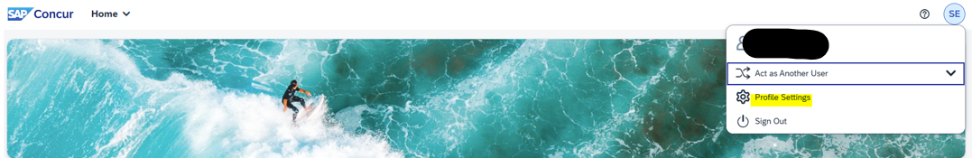

1. Click on “Personal Information”

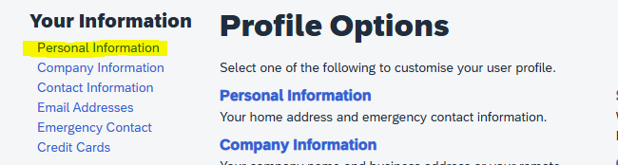

1. Scroll through this page completing only the fields marked **[Required]** clicking 

after you complete each section

#### Personal Information





#### Contact Information

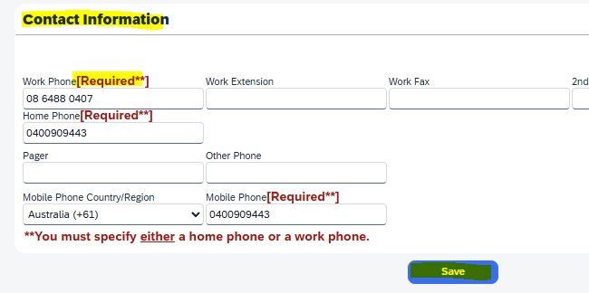

#### Email Address

Enter your email address and click on VERIFY



#### Emergency Contact

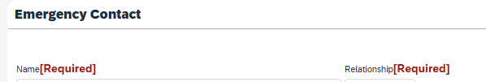

#### Travel Preferences

**Travel Preferences:** Only complete the **[Required]** boxes



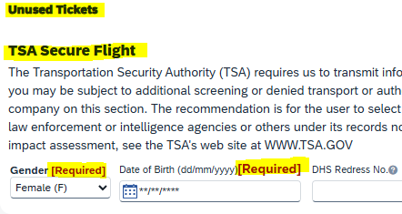

### **Creating a New Concur Request**

Follow the step-by-step instruction below to create and upload your approved travel booklet on to your Concur Request.

**IMPORTANT INFORMATION:**

* This process is ENTIRELY for **Insurances purposes ONLY**.
* This process WILL NOT generate your travel reimbursement.
* You **MUST ENTER** the **AMOUNT as $0.00**
* It must be completed **BEFORE YOU TRAVEL**

1. Once your Travel Book has been approved and returned to you, log in to CONCUR to create a Concur Request.
2. Go to “Create” and select “Start a Request”

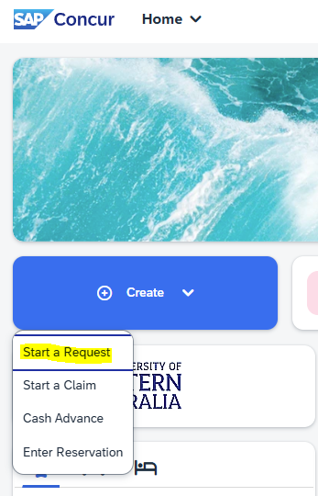

1. You are required to complete the following fields. Please see example screenshot below the table.

|  |  |
| --- | --- |
| Required Field | Instruction |
| Booking Type | Click on the drop-down menu and select “**Concur REQUEST**” |
| Trip Name | Make sure you name it [destination] + [month and year]  For example: *Geraldton Nov/Dec 23* |
| Departure Date and Return Date | Enter the date of departure and return as discussed and approved in Section one of your booklet  **Note:** If you are unable to enter the dates, check the Booking Type you select. If it is “Concur TRAVEL”, please cancel and start again. |
| Number of Travel Days | This will be automatically calculated based on the Departure and Return Date you have entered |
| Travel Service Provider | Select “**No Quote Required**” from the drop-down menu |
| Travel Purpose | Select “**Student Placement**” from the drop-down menu |
| Trip Description | Provide further information about your trip in the format of:  *[Unit Code] + [Host Organisation] + [Region] + [Month and Year]* |
| Indicate the main high-risk activity | Select from the category below that is closest to your internship travel:   * Biohazard work * Chemical * Close to high-risk activity (e.g., army base in conflict zone) * Fieldwork * Higher-risk motor vehicle travel 4x4 unsealed/non-maintained roads * In-country flights in developing country/charter & light planes * Isolated/rural/remote * Local contentious issues Political or Religious |
| I confirm PG Mgr. Approval & Funds Availability | Yes |

**EXAMPLE: Concur Request**

1. Once you have created the fields listed in Step 3, you should be able to see this on your browser’s main screen.

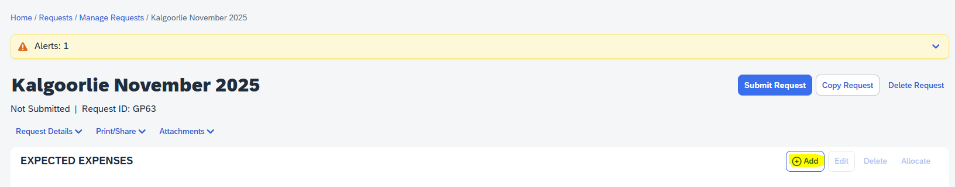

1. Click the “**Add**” button to enter details of your approved **FORM 2 Travel Itinerary** by listing the different travel expenses category (e.g., Air Ticket, Hotel Reservation, Rail/Bus, and any other categories that are applicable).

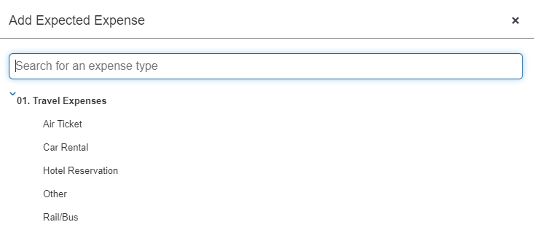

**Tips:** If your approved itinerary consists of more than one travel expenses category (e.g., Rail/Bus and Hotel Reservation), you can repeat Step 5 if you have any additional Travel expense. Continue adding the different travel expenses category **under the same Concur Request ticket** that you are currently working on. You do not have to create separate Concur Request for each travel expenses category. See examples below.

**Example – Air Ticket**

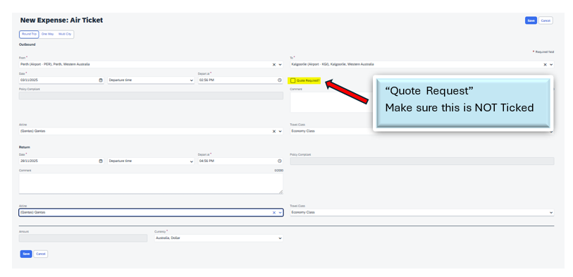

**Example – Other – Fuel Cost**

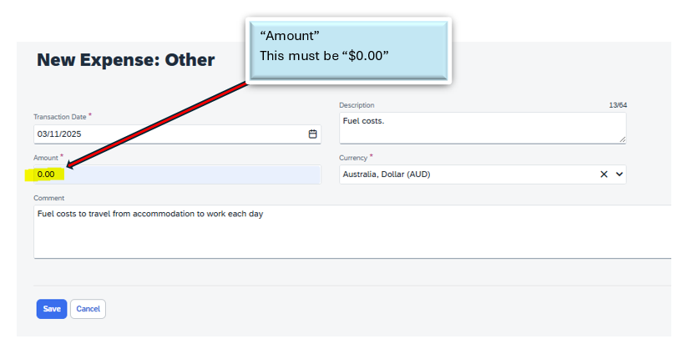

1. Fill in the required fields and ensure you have unticked the “Quote Required?” box and entered $0.00. Select “Save” to submit.
2. You will be shown a similar view on your Concur Request ticket dashboard as screenshot below. Repeat Step 4 if you have more than one Travel Expenses category to add. Otherwise, go to Step 8.

**Example Concur Request Summary – More than one Expected Expense**

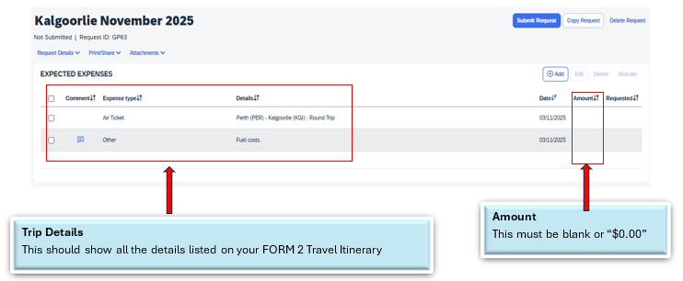

1. Select ‘Attachments” to upload your **Approved Travel Booklet** – See Screenshot below.

**Note:** The maximum file size is 5MB and you can only upload one attachment.

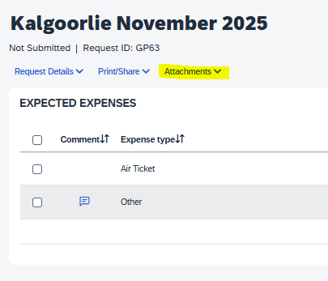

1. Select “Submit Request” button once you have finalised all details of your travel.

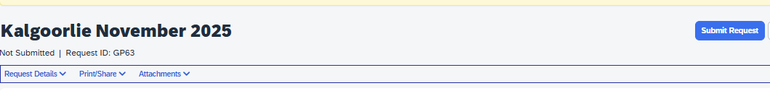

1. Please ensure you check the status of your Concur REQUEST ticket – [**Submitted**] or [**Approved**]

**Note:** If your Concur REQUEST ticket status showed “Cancelled” by Approver, please contact [internships@mccuskercentre.uwa.edu.au](mailto:internships@mccuskercentre.uwa.edu.au) immediately.